Wing Chun Full Contact Competition Rules

CONTENTS
Chapter 1 General Rules
Article 1 Types of Competition
Article 2 Systems of Competition
Article 3 Qualifications and Requirements
Article 4 Weight Categories
Article 5 Weighing-in
Article 6 Drawing Lots
Article 7 Dress and Protective Gear
Article 8 Competition Protocol
Article 9 Default
Article 10 Other Relevant competition Provisions
Chapter 2 Officials and their Duties
Article 11 Officials
Article 12 Support Staff
Article 13 Duties of Officials
Chapter 3 Competition Methods, Scoring Criteria and Penalties
Article 14 Fighting Techniques
Article 15 Prohibited Methods
Article 16 Prohibited Areas
Article 17 Competition mode
Article 18 Scoring Areas
Article 19 Scoring Criteria
Article 20 Fouls and Penalties
Article 21 Temporary Suspension of Contest

Chapter 4 Winning and Placing
Article 22 Determination of Wins and Losses
Chapter 6 Arrangement and Recording of Competition
Article 23 Arrangement of Competition
Article 24 Recording
Chapter 6 Calls and Gestures
Article 25 Platform Referee’s Calls and Gestures
Article 26 Sideline Referee’s Gestures
Chapter 8 Competition Area and Equipment
Article 27 Competition Area
Article 28 Equipment

CHAPTER 1

GENERAL RULES
Article 1 Types of Competition
  - Individual: individual results are used to obtain individual ranking.

Article 2 Systems of Competition
2.1 The competition system will be divided into single or multiple groups with single and double elimination based on the competition scale and number of participants.
2.2 Each bout consists of three one-and-a-half-minute rounds with a one-minute rest in between. A bout is won by the best of three rounds.
Article 3 Qualifications
3.1 The competitor must hold a passport issued by the country/region which he represents.
3.2 Types of competition:
→ Full protection ( helmet with mask，Guard，Elbow protector，shinpad，boxing glove)
→ Part protection (helmet-no mask，Elbow protector，shinpad，boxing glove)
3.3 Age Requirement:
Adult group: (Aged 18 or above)
3.4 Gender : Female and Male.
3.5 The competitor must produce a personal insurance certificate.
3.6 The competitor must produce a health certificate showing his/her body condition is good within 20 days before his registration.

Article 4 Weight Categories
4.1 50kg Category (Under ≤50kg)
4.2 55kg Category (＞50kg－≤54.9kg)
4.3 60kg Category (＞55kg－≤59.9kg)
4.4 65kg Category (＞65kg－≤69.9kg)
4.5 70kg Category (＞65kg－≤69.9kg)
4.6 75kg Category (＞70kg－≤74.9kg)
4.7 80kg Category (＞75kg－≤79.9kg)
4.8 85kg Category above (＞80kg or above)

Article 5 Weighing-in
5.1 After the inspection has been qualified, competitors shall be weighed by the chief registrar in collaboration with the scheduler-recorders under the supervision of the Competition Committee.
5.2 Only competitors with credentials shall be weighed in. They must show their passports at the time of weighing-in.
5.3 Competitors shall be weighed in at the designated place and at the designated time, either in the nude or only with their trunks on. (Female competitors may wear close-fitting undergarments.)
5.4 The weighing-in shall start with the lighter weight categories, each to finish in an hour. A competitor who outweighs his entered category and fails to reduce his weight within the stipulated time shall not be allowed to compete in any of the subsequent contests.

** (a) Applicants need to select the accurate weight group
- During weigh-in process, if the applicant’s actual weight is lower than the selected weight group, applicants still need to compete in the selected group.
- During weighing-in process, if the applicant’s actual weight is heavier than the selected weight group, applicants need to compete in a higher weight group.

Article 6 Drawing Lots
6.1 The drawing-lots ceremony shall be conducted by the scheduling-recording group, in the presence of the chairman of Jury of Appeal, the chief referee and team coaches or team leaders.
6.2 The drawing-lots ceremony shall take place after the first weighing-in, starting with the lighter weight categories. Any category with only one competitor shall be excluded from the contest.
Article 7 Dress and Protective Gear
7.1 Competitors shall wear 1) 6oz boxing gloves( with fingers exposed), 2) elbow protectors, 3) shin protectors , 4) headgear and 5) chest protectors designated by the Competition and use their own gum shields and cup protectors (under their trunks). Competitors' wear and protective gear shall be either red or black.
7.2 Competitors must wear a T-shirt with sleeves (short) and long pants.

All-round protective gear
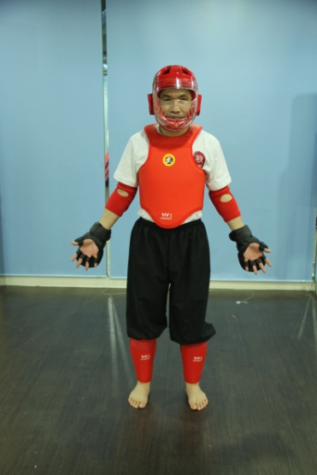 All-round protective gear
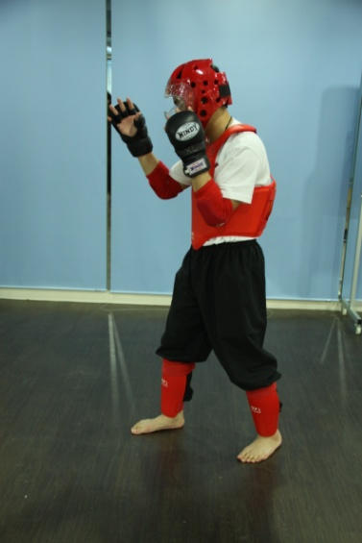 2 side protective gear
(The above photo is just for information, the competition committee will provide the actual details of the real sample)
Article 8 Competition Protocol
8.1 “Referee entering”: Referees line up and enter the area. They shall stand on the edge of the area in the center and face the Head Referee. The one who is being introduced shall step forward and give a fist-palm salute to the audience. Then, the sideline referee shall go and stand at the side of the area and face the platform.
8.2 Sideline referees shall exchange fist-palm salute at the time of replacement.
8.3 “Competitors entering”: Competitors shall stand near to the platform referee on both sides and face the Head Referee after entering the area. Competitors shall step out and give a fist-palm salute when they are introduced to the audience and then exchange fist-palm salute with the other competitors.
8.4 Each round shall start with a fist-palm salute on the platform from both sides to their respective coaches, who shall answer with the same salute.
8.5 At the announcement of the result, the two competitors shall exchange their positions. After the announcement, they shall give a fist-palm salute to each other and then simultaneously to the platform judge, who shall answer with the same salute, and then to the opponent's coach, who shall answer with the same salute.
8.6 At the end of every competition, before leaving the platform, competitors have to give fist-palm salute to the referee after listening to the result announcement declared by the leading referee.
Article 9 Default
9.1 A competitor who is unable to compete due to injury or illness, which must be proved by a platform doctor’s prescription, or who is not qualified for competition due to being overweight, shall be considered as a default, and shall not be allowed to take part in the subsequent contests. However, his results achieved in previous placings shall count.
9.2 If a competitor is being outclassed, his coach may, for the sake of safety, show the default plate. The competitor may also raise his hand to request a default.
9.3 A competitor who is absent for weighing-in, or who fails to answer the three roll-calls prior to a bout, or who leaves after the roll-calls without permission and fails to appear in time in the competition area, shall be regarded as a groundless default .
9.4 A competitor who makes a groundless default shall have all his results cancelled.
Article 10 Other Provisions in Competition
10.1 Signals used during the bout:
(1) Before starting the bout, the timekeeper shall whistle 5 seconds earlier to inform the competitors to get ready while beating the gong to announce the competition is finished.
(2) The leading referee shall use commands and gestures to judge the competition.
(3) Sideline referee shall use gestures to co-operate with the judgment of the leading referee.
10.2 Other rules and regulation:
10.2.1 Referee:
(1) All officials on duty shall concentrate on their work, without talking among themselves. Nor shall they leave their seats without the referee’s permission.
10.2.2 Competitors:
(1) All participating teams shall abide by the Rules and respect and obey the judges' decisions. It is prohibited to wrangle, curse, throw protective gear, or act in any way to vent discontent. They shall treat the bout seriously and not hurt others on purpose.
(2) The team coach and doctor may be seated at the designated place and are allowed to give massage or guidance to their athletes during the rest periods between the rounds.
(3) Competitors are not allowed to request a pause during the bout. If any special situation occurs the leading referee has to be informed. Competitors are not allowed to walk out (except in cases of first-aid emergency) before the announcement of the result of the bout.
(4) Competitors are not allowed to have long fingernails when participating in a bout.
(5) Doping is strictly prohibited. Infusion of oxygen is forbidden during the rest periods between the rounds.

CHAPTER 2

OFFICIALS AND THEIR DUTIES
Article 11 Officials
11.1 The Chief Referee Group: There shall be one (1) chairman, one (1) ) deputy chairman and 4-6 committee members which will be highest authority to oversee the whole competition and appeals.
11.2 Referee Team in different locations: It will consist of one (1) head referee, 1 -2 deputy head referee, one (1) platform referee, 4 or 5 sideline referees, one (1) recorder and one (1) timekeeper.

Article 12 Supporting Staff
12.1 2 - 3 scheduler-recorders (includes one chief)
12.2 2 - 3 registrars (includes one chief)
12.3 1 – 2 announcers
12.4 2 – 3 medical staff

Article 13 Duties of Official
Under the lead of the Committee, referees shall treat their judging work seriously, earnestly, fairly and accurately. The following are their responsibility:
13.1 The Chief Referee Group shall:
(1) Organize all officials to study the Rules and Regulations of the Competition, and to master the officiating methods.
(2) Make sure that everything is ready for competition in regard to the platform, equipment and officiating apparatus, and to the weighing-in, drawing of lots and programming.
(3) Settle problems according to the Rules and Regulations;
(4) Provide guidance to referees in competition and replace officials if necessary.
(5) Notify the referee, chief schedule-recorder and announcers in time if any change has occurred in the order of competition owing to a competitor’s default.
(6) To hear appeals and make final decisions when a dispute arises in a judgment.
(7) Monitor that the officials are implementing the Rules properly.
(8) Hand in the summary in hard copy to the Committee
13.2 Head Referee shall:
(1) Organize his referee team’s work and study.
(2) Supervise and guide the work of the referees, timekeeper and recorder.
(3) Whistle as a hint for correction, before the final result is announced, when the platform referee has made an apparent misjudgment or omission.
(4) After consulting the opinion of Deputy Head Referee, the Head referee may correct the judgment.
(5) Announce the result at the end of each round to decide the winner.
(6) Handle such matters as absolute victory, fall-off, penalty and forcible counting according to the competitors’ conditions on the platform and the recorder’s records.
(7) Examine and sign the results at the end of each bout.
(8) Unless the judgment is overridden by the Competition Committee, the decision of the Head Referee is final. No appeal is allowed.

13.3 The Deputy Head Referee
The Deputy Head Referee shall assist the referee, act as Head Referee when the Head Referee is absent, and perform other officials’ tasks assigned concurrently when necessary.
13.4 The Platform Referee shall:
(1) Strictly follow the rules and make just judgment
(2) Check the competitors' protective equipment and ensure safety in fighting.
(3) Guide the fights through commands and gestures.
(4) Make decisions on such matters as fall-down, fall-off, penalty, forcible counting and call for first aid.
(5) Announce the result of a bout.
13.5 The Sideline Referees:
(1) Award points to the competitors according to the Rules.
(2) Display the results simultaneously and instantly at the head referee’s signals at the end of each round.
(3) Sign the scorecard at the end of each bout, to be kept for examination and verification.
13.6 The Recorder shall:
(1) Record the score of the competitors based on the referee’s judgment.
(2) Participate in the work of weighing-in procedure and record the competitors' weights in the statistical chart of the bout.
(3) Record the numbers of warnings, admonitions, forcible counts and falls-off according to the platform judge’s calls and gestures.
(4) Calculate the final score for the winner of each round according to the sideline judges’ win/loss decisions and report to the head judge.
(5) Display the judges’ results instantly based on the signals of the chief referee after each round.
(6) Sign on the list of scoring record after each competition and keep it for examination or inspection once needed.
13.7 The Timekeeper shall:
(1) Check the gong and timing devices before the competition; make sure that the stop-watches are accurate.
(2) Keep a record of the time elapsed during the fights, stops and rest periods between the bouts.
(3) When the computer scoring system is not available, blow a whistle ten (10) seconds before the start of each round and beat a gong to announce its end.
(4) Read out the sideline referee’s decision.
13.8 The Scheduler-Recorders shall:
(1) Be responsible for examining the competitors' credentials and entry forms.
(2) Organize the drawing-lots ceremony and work out the competition schedule.
(3) Prepare various forms to be used in competitions; check and verify the competitors’ results to determine their placings.
(4) Record and announce the results of all bouts.
(5) Collect data for statistics and compilation of Results.
13.9 The Registrars shall:
(1) Be responsible for the competitors’ weighing-in ceremony.
(2) Be responsible for the preparation of protective gear and its management during the Competition.
(3) Summon the competitors for roll-calls twenty (20) minutes before the start of a contest.
(4) Report to the chief referee immediately in cases of absence or default during the roll-calls.
(5) Check the competitors’ dress and protective gear as required by the Rules.
13.10 The Announcers shall:
(1) Give the audience a general idea of the Rules and Regulations of the Competition.
(2) Introduce the referees and competitors to the audience.
(3) Announce the results of competitions.
13.11 The Medical Workers shall:
(1) Check the competitors’ health proof.
(2) Carry out anti-doping tests in cooperation with the experts.
(3) Conduct selective checkups among the competitors before the competition.
(4) Provide first-aid service to injured or sick competitors during the Competition.
(5) Examine cases of injury caused by fouls.
(6) Be responsible for medical supervision and propose to the chief referee promptly to suspend injured or sick competitors from competition.

CHAPTER 3

COMPETITION METHODS, SCORING CRITERIA AND PENALTIES
Article 14: Fighting Methods
14.1 All kinds of Wing Chun techniques including fist, palm, elbow, knee, leg footwork, circle-feet (圈脚), straight kicks, side kicks and dropping kicks, low sweeping leg in order to beat down encountering party ( no whip leg, no score will be given if the encountering party is not down ) and wrestling techniques;
14.2 If the competitor uses techniques other than Wing Chun techniques such as big hook punch, big throwing punch, chopping punch, sweeping punch, turning kick, twister kick, backward kick, a verbal warning will be given and no points will be awarded. (If non-Wing Chun techniques are used twice, one point will be deducted (for technical foul), if non- Wing Chun techniques are used four times, two points will be deducted.) even if no effective attack is made.
14.3 If a competitor uses non-Wing Chun techniques as stipulated in 14.2 above and hurts his opponent , provided the opponent can continue fighting, the competitor will be penalized by deducting 2 points. (Serious foul) If the opponent is knocked down and unable to continue fighting, the competitor will be disqualified so the opponent will be the winner of that bout.
Article 15: Prohibited Areas
The back of the head, the throat, the crotch, the area at the back of the neck and the whole of the back.

Article 16: Prohibited Methods
16.1 Attacking opponent’s eyes by using fingers.
16.2 Attacking opponent by using head or teeth.
16.3 Pulling or dragging hair.
16.4 Using a wrestling technique which will make the opponent’s head fall to the floor first or intentionally smashing or pressing his opponent down on the floor.
16.5 Twisting the opponent's joints directly and intentionally.
16.6 Strangling.
16.7 Hitting the opponent’s head when he is already down.
16.8 Deliberately attacking the neck area.
16.9 Catching hands with others to wrestle
16.10 Pulling the opponent’s protective gear.
16.11 Cannot hold up the opponent and flow him down on the floor

Article 17: Competition mode
At the beginning of a bout or after separating or pausing, the athletes must wait for the referee to give the order before starting to attack.
If an athlete falls or moves out of the ring, both competitors must return to the centre in order to resume.
Article 18: Scoring Areas
The head, trunk and thighs (the kneecap or below will not carry points)

Article 19: Scoring Criteria
19.1 Two (2) points score
(1) When a competitor is beaten to the floor and the attacker can still stand on the stage, the attacker will get 2 points. If the attacker also falls on the floor, no score will be given.
(2) Effective kick against the opponent’s head or trunk – 2 points.
(3) When the opponent is given a forcible counting (at least 10 secs) – 2 points
(4) When the opponent receives a serious warning – 2 points
(5) If an athlete repeats an offence for the second time, the bout will be awarded to the opponent.
19.2 One (1) points score
(1) When he hits the opponent’s head with the elbow or palm attack technique;
(2) When he uses the knee to purposely hit the opponent’s torso (but no score will be awarded for hitting the head or other parts of the body with the knee);
(3) Use Wing Chun kicks to hit the opponent’s thigh;
(4) When the fall down of the opponent is caused by the fall down of the attacker purposely and the attacker can still get in a stand up position, he can get 1 point. (自已倒地意圖摔倒對方)
(5) When the fall down of the opponent cannot cause the competitor to fall down, the competitor gets 1 point.
(6) When the opponent fails to attack within eight (8) seconds after the order to attack is given;
(7) When the opponent fails to stand up within three (3) seconds after falling down on purpose to wrestling down his competitor;
(8) When the opponent receives a technical warning.
19.3 No Point will be Awarded
(1) When the techniques he uses are not clear and ineffective;
(2) When both sides fall on or off the platform at the same time;
(3) When he hits the opponent in a clinch.(緾繞中攻擊)
(4) Just use single hand, double hand or body but not Wing Chun technique to push the opponent off the platform.

Article 20 Fouls and Penalties
20.1 Verbal warning (no point deduction)
The platform referee can, according to the circumstances, issue a verbal warning,
- When non – Wing Chun techniques are used but not actually attack or hit the opponent.
- Repeatedly use non – Wing Chun techniques to attack, although not effective, the platform referee should give a technical warning (deduct one point) / serious warning (deduct two points).

20.2 Technical Fouls
(1) When he holds the opponent passively or runs away passively with no intention to fight. The platform referee may order the passive party to start attack within 8 seconds, fail to attack within 8 seconds is a technical foul
(2) When he raises his hand to request to suspend competition while he is in a disadvantageous situation;
(3) When he delays the fight intentionally;
(4) When he acts impolitely towards the referee or disobeys their decisions;
(5) When he wears no gum shield or spits out his gum shield, or loosens his protective gear intentionally or his opponents;
(6) When he fails to observe the protocol.
(7) Whether intentionally or not, athletes will be prohibited from pulling opponents’ clothes or protective gear.
(8) When both sides linger for 3 seconds without any attacking action, they should be separated.
20.3 Serious Foul
(1) When he attacks the opponent before the call of "Hoi Te (Start)!” or after the call of "Ting (Stop)!”
(2) When he hits the opponent in prohibited areas of the body;
(3) When he hits the opponent with any prohibited method.
(4) If the opponent is injured by using non-Wing Chun tricks resulting in reduced power (the opponent can still continue the bout).
20.4 Penalties
(1) An admonition is given for a technical foul. 1 point will be given to the other party.
(2) A warning is given for a serious foul. Two(2) points will be given to the other party.
(3) A competitor who commits two serious fouls will be disqualified from that round and the opponent declared the winner.
(4) A competitor who hurts the opponent intentionally will be disqualified from the whole competition, with all his results annulled.
(5) A competitor who uses prohibited substances or inhaling oxygen during the rest period will be disqualified from the whole competition, with all his results annulled.

Article 21 Temporary Suspension of Competition
The competition will be temporarily suspended; (time count hold)
(1) When a competitor falls on or off the platform (except for a purposeful fall);
(2) When a competitor is penalized;.
(3) When a competitor is injured.
(4) When the competitors hold each other in a clinch for more than three (3) seconds without launching effective attacks, or run away passively;
(5) When a competitor falls on purpose and remains down for more than three (3) seconds; (主動倒地)
(6) When a competitor raises his hand to request a suspension of the fighting for objective reasons such as loose protective gear.
(7) When the chief referee rectifies a misjudgment or omission.
(8) When some problem or dangerous incident happens on the platform;
(9) When competition is interrupted for some objective reasons such as improper lighting or poor condition of the platform;
(10) When no attack is launched for eight (8) seconds after the order to attack is given.

CHAPTER 4
WINNING AND PLACING
Article 22 Determination of Wins and Losses
22.1 Absolute Victory
(1) In a one-sided bout, the technically stronger will be declared the winner of the bout by the platform judge with the referee’s approval.
(2) During a bout, when a competitor who is knocked down and fails to get to his feet within ten (10) seconds (except for serious fouls), or who has managed to get to his feet but remains in an abnormal state of consciousness, the attacker will be the winner of the whole bout. (Forcible count)
(3) During a bout, the competitor whose opponent has been forcibly counted (even if the count did not reach 10) three times after receiving heavy blows (except for personal fouls), will be declared the winner of the bout.
22.2 Determination of the Winner of a Round:
(1) The result of each round will be decided by the side judges.
(2) During a round, when a competitor who is forcibly counted two (2) times after receiving heavy blows (except for serious fouls), his opponent is the winner of that round.
(3) In case of an equal number of points awarded in a round, the winner will be decided in the following order:
1. The competitor with fewer warnings will be declared the winner.
2. The competitor with fewer admonitions will be declared the winner.
3. The competitor with a lighter weight on the day of the contest will be declared the winner.
(4) If the tie remains, the round is a draw.

22.3 Determination of the Winner of a Bout
(1) The competitor who wins two rounds will be the winner of the bout.
(2) During the fighting, if a competitor is sudden illness, as certified by the doctor, unable to continue the competition, the opponent will be declared the winner of the bout.
(3) During the fighting, if a competitor feigns injury when a foul is committed by the opponent – an injury as later proved by medical supervisors to be faked, the fouling side will be declared the winner of the bout. The competitor who pretends to be hurt will be the loser.
(4) The competitor who is injured by the opponent in a foul and, as confirmed by medical supervisors, unable to continue the fight, will be declared the winner of the bout, but he will be barred from subsequent contests.
(5) Under the elimination system, an equal number of rounds will be handled as follows:
1. The competitor with fewer warnings will be declared the winner.
2. The competitor with fewer admonitions will be declared the winner.
If the tie remains, an additional round will be held.

CHAPTER 5
ARRANGEMENT AND RECORDING OF COMPETITION

Article 23 Arrangement of Competition
23. 1 Preparations for the Arrangement
23.1.1 Study the Regulations for a full understanding of
(1) The types and methods of competition
(2) The schedule of the Competition
(3) The classification of weight
(4) The eligibility of participation and number of participants
(5) The placing and prize-awarding methods
22.1.2 Examination of entry forms (Table 1)
22.1.3 Statistics of competitors in each weight category
23.2 Arrangement Guidelines
(1) All arrangements shall be made in accordance with the Regulations and on the basis of entry forms and general schedule of the Competition.
(2) Contests of the same weight category and the same round should be comparatively concentrated and arranged on an equal basis.
(3) At most two bouts (in different sessions) can be arranged for a competitor in one day.
(4) Contests in the same session shall start with the lighter weight categories.
23.3 Arrangement Methods
(1) Work out the rounds of competition and the number of bouts of each category according to the system of competition.
(2) Compile a competition schedule (Table 2).
(3) Work out the rounds of each category (Table 3).
(4) Compile a Program for all bouts
(5) Under the elimination system, the method of “drawing lots to decide the odd” may be adopted.

Article 24 Recording
24.1 The sideline judges shall keep a record of the points awarded to each competitor according to the scoring criteria and the platform referee’s decisions. At the end of each round, they shall enter the competitors’ scores into the scorecard (Table 4).
24.2 The recorder shall keep a separate record of the admonitions, warnings, disqualification, and forcible counting (Table 5).
24.3 During the round robin, scheduler-recorders shall record the score on the list based on the result of each bout. 2 marks for the winner and 0 mark for the loser while 1 mark for each competitors if the bout is a draw. If the opponent abstains from participating in the bout, the competitor can get 2 marks and the opponent gets 0 marks.

CHAPTER 6

CALLS AND GESTURES

Article 25 Platform Referee’s Calls and Gestures
25.1 Fist-Palm Salute
In a standing position with feet together. place the left palm against the right fist in front of and 20-30 cm away from the chest. (Figs 1 and 2).
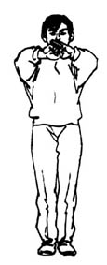 Fig 1 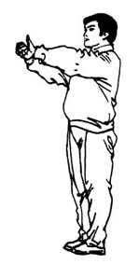 Fig 2
25.2 Mount the platform
Standing at the center of the platform, extend both arms sideways, palms up and pointing at the competitors (Fig 3). As a call is given to them to mount the platform, bend both arms at the elbow into a right angle, palms facing each other (Fig 4).
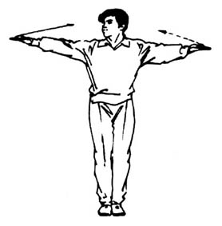Fig 3 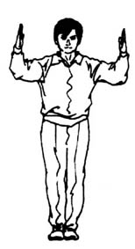 Fig 4

25.3 Competitors salute each other
Place the left hand on top of the right fist in front of the body as a signal to both competitors to salute each other (Fig 5).
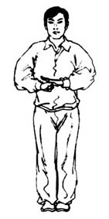Fig 5
25.4 First round
Facing the head judge, take a bow stance and, while calling “Diyiju（First round）!” extend one arm forward with the index finger pointing up and the other three fingers and the thumb clenched into a fist (Fig 6).
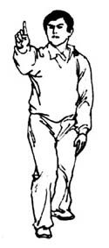Fig 6
25.5 Second round
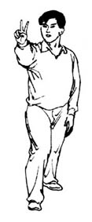
Facing the head judge, take a bow stance and, while calling “Di’erju（Second round）!”, extend one arm forward with the index and middle fingers separated and pointing up, and the thumb and the other two fingers clenched (Fig 7).

Fig 7
25.6 Third round
Facing the head judge, take a bow stance and, while calling “Disanju (Third round)!”, extend one arm forward with the thumb and the index and middle fingers separated and pointing up and the other two fingers clenched (Fig 8).
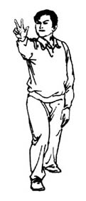Fig 8
25.7 “Yubei – Kaishi (Ready – Start)”
Take a bow stance between the two competitors and, while calling “Yubei (Ready)!" extend both arms sideways, palm facing up and pointing at the competitors (Fig 9). Then, while calling “Kaishi (Start)!” cross palms in front of the abdomen (Fig 10).
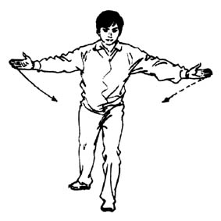Fig 9 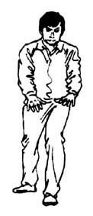Fig 10

25.8 "Ting (Stop)!”
While calling "Ting (Stop)!” take a bow stance and insert one extended arm between the two competitors, fingers pointing up (Figs 11-12).
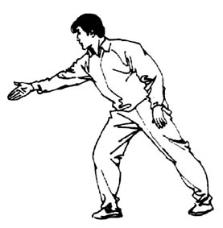Fig 11 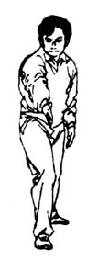Fig 12

25.9 8-second passivity
While calling "Hongfang (Red side)!” or “Heifang (Black side)!” raise both hands in front of the body, with the small and ring fingers of one hand bent and the thumbs and other fingers of both hands separated and stretched naturally (Fig 13).
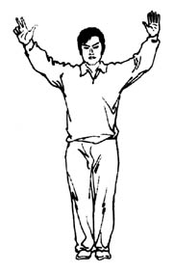 Fig 13

25.10 10 Count
Facing the fallen competitor, with both arms bent at elbow and both hands clenched into fists in front of the body, palm side facing forward, unbend the fingers one by one from the thumb to the little finger, at an interval of one (1) second (Figs 14-15).
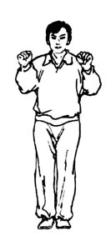 Fig 14 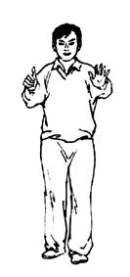 Fig 15
25.11 Passive hold
Fold the arms in front of the body (Fig 16).
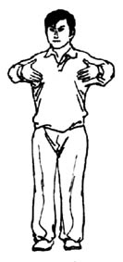 Fig 16
25.12 10-second forcible counting
Facing the head judge, extend one arm with the thumb pointing up and the other fingers clenched (Fig 17)
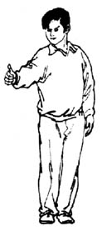 Fig 17

25.13 Three seconds
While calling "Hongfang (Red side)!” or “Heifang (Black side)!” extend one arm obliquely (傾斜地) up with the palm straight and pointing at the competitor. Meanwhile, move the other hand across the abdomen(腹部)to the side of the body, with the thumb and the index and middle fingers separated naturally and the other two fingers clenched (抓緊) (Fig 18).
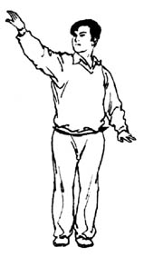 Fig 18
25.14 Appointed attack
Extend one arm between the two competitors, with the thumb extended and the fingers clenched, palm side down. While calling “Hongfang (Red side)!” or “Heifang (Black side)!” move the hand horizontally in the direction of the thumb as a signal for appointed attack (Fig 19).
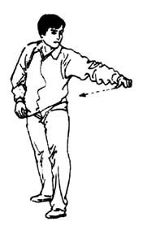 Fig 19

25.15 Down
While calling "Hongfang (Red side)!” or “Heifang (Black side)!” extend one arm with palm facing up and pointing at the fallen competitor, as the other arm moves to the side of the body, bent at elbow and with palm facing down (Fig 20).
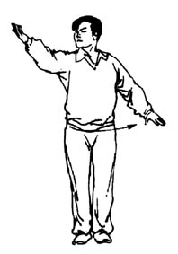 Fig 20

25.16 Down First
Extend one arm towards the competitor who is the first to fall down and, while calling "Hongfang (Red side)!” or “Heifang (Black side)!” cross the arms in front of the abdomen, palms facing down (Figs 21-22).
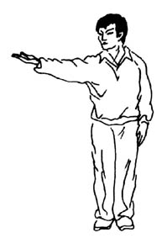 Fig 21 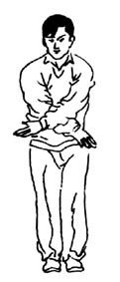 Fig 22

25.17 Simultaneous fall
Extend both arms horizontally forward and withdraw them to press both palms down (Fig 23).
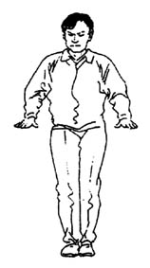 Fig 23
25.18 Kick the crotch
Extend one arm towards the offender and, while calling "Hongfang (Red side)!” or “Heifang (Black side)!” point the other hand at the crotch, palm facing inward (Fig 24).
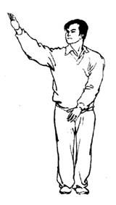 Fig 24

25.19 Hit the back of head
Extend one arm towards the offender and, while calling "Hongfang (Red side)!” or “Heifang (Black side)!” place the other hand on the back of the head (Fig 25). If the offender attacks the throat or pokes the eyes, the referee should indicate the area attacked.
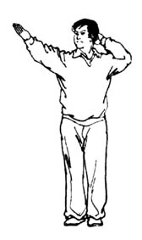 Fig 25
25.20 Serious warning
Extend one arm towards the offender, palm up. While calling "Hongfang (Red side)!” or “Heifang (Black side)!” bend the other arm at elbow into a right angle, fingers clenched into a fist with the thumb side facing outward (Fig 26).
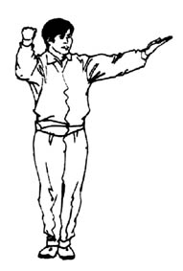 Fig 26

25.21 Technical warning
Extend one arm towards the offender, palm up. While calling "Hongfang (Red side)!” or “Heifang (Black side)!” indicate the foul with the other hand and bend the arm at elbow into a right angle in front of the body, fingers pointing up and palm facing backward (Fig 27). For a verbal warning, the referee only needs to point to the offender and indicate a foul has taken place resulting in a verbal warning.
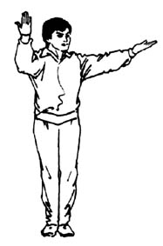 Fig 27
25.22 Disqualification
While calling "Hongfang (Red side)!” or “Heifang (Black side)!” clench both hands into fists and cross the forearms in front of the body (Fig 28).
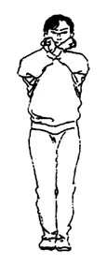 Fig 28

25.23 Not valid
Extend both arms and cross them in a swing in front of the abdomen (Figs 29.30.31).
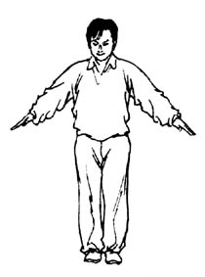Fig 29 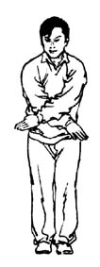Fig 30 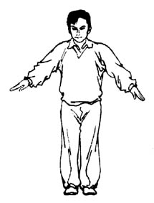Fig 31
25.24 Emergency treatment
Facing the medical supervision desk, cross forearms in front of the chest, fingers pointing up (Fig 32)
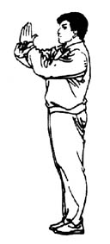 Fig 32
25.25 Rest
Extend both arms sideways, palms up, to point at the competitors’ rest places (Fig 33).
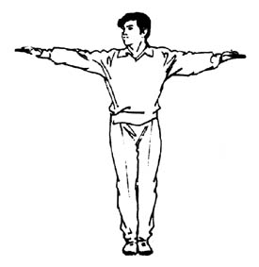 Fig 33

25.26 Exchange positions
Standing at the center of the platform, cross arms in front of the abdomen (Fig 34)
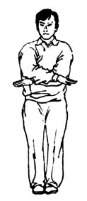 Fig 34
25.27 Draw
Standing between the competitors, hold their wrists and raise their hands. (Fig 35).
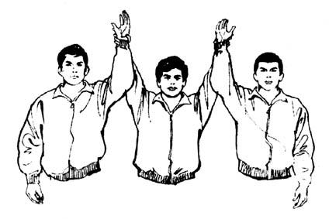 Fig 35
25.28 Winner
Standing between the competitors, hold the winner‘s wrist and raise his hand (Fig 36).
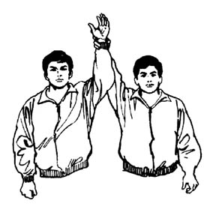 Fig 36

Article 26 Sideline Referee’ Gestures
26.1 Off or down
Point down with a forefinger, with the other four fingers clenched (Fig 37).
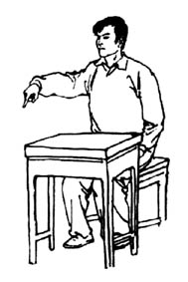 Fig 37

26.2 Not off or down
Move one hand from side to side once, fingers pointing up (Fig 38).
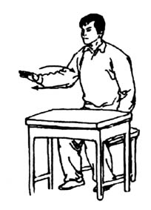 Fig 38
26.3 Not seen clearly
Bend both arms at elbow and spread forearms sideways in front of the body, palms up (Fig 39).
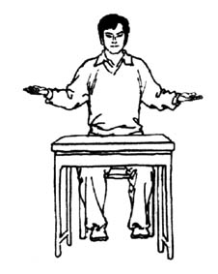 Fig 39

CHAPTER 7

COMPETITION AREA AND EQUIPMENT

Article 27 Competition Area
26.1 The competition area shall be a 5M x 5M platform, possibly surrounded by rope.

Article 28 Equipments
28.1 Colored Plates
A total of eighteen (18) plates -- six (6) in black, six (6) in red, and six (6) half in red and half in black -- are used by the sideline judges to indicate the winner, the loser and a drawn bout respectively. The plate is a disc 20 cm in diameter, with a wooden handle 20 cm in length (Fig 1).
28.2 Technical warning
Twelve (12) 15cmX5cm yellow cards are used for admonition, with the Chinese characters “技術警告” on them (Fig 2).
28.3 Serious warning
Six (six) 15cmX5cm red cards are used for warning, with the Chinese characters “嚴重警告”on them (Fig 3).
28.4 Card Racks
Two (2) racks -- one in black and one in red -- are used for holding the cards. They are 60 cm long and 15 cm high (Fig 4).
28.5 Default plates
Two (2) yellow plates are used for default, with the Chinese characters “棄權” on them ― written in red color on one side and in black color on the other side. The plate is a disc 40 cm in diameter, with a wooden handle 40 cm in length (Fig 5).
28.6 Two (2) stop-watches (one as reserve)
28.7 Two (2) whistles (one with single pitch, the other with double pitches)
28.8 Three (3) megaphones
28.9 One (1) gong, with a rack and a hammer
28.10 Fifteen to twenty (15-20) tally counters
28.11 Two (2) video cameras
28.12 Two (2) metric scales
28.13 Three (3) wireless microphone (to be pinned on the platform judge’s chest)
28.14 One (1) set of electronic scoring system

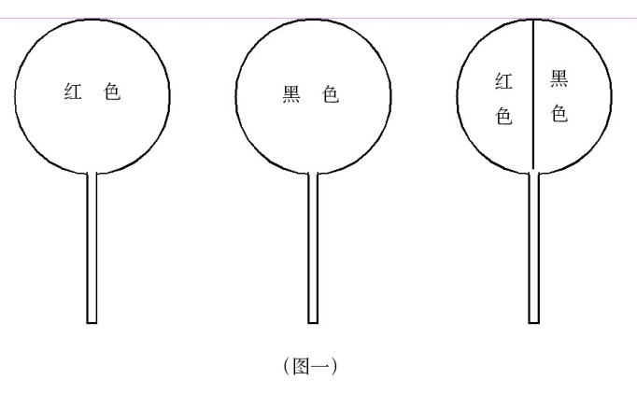
Fig 1

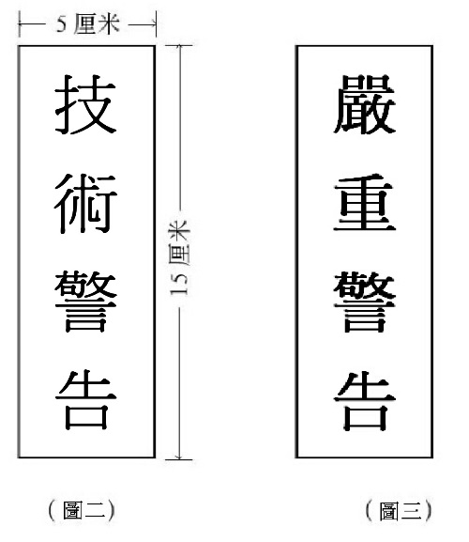
Fig 2 Fig 3

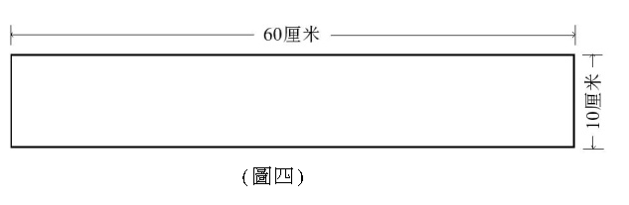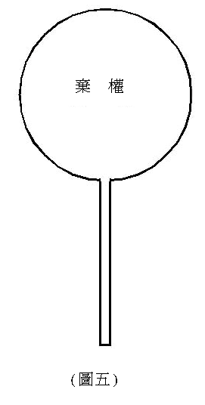
Fig 4 Fig 5
Full Contact Competition Entry Form (Table 1)
Country/Region： Team Leader： Coach： Doctor：
No. | Name | Sex | Birth y/m | Bodyweight | 48kg | 52kg | 56kg | 60kg | 65kg | 70kg | 75kg | 80kg | 85kg | 90kg | Over 90kg | Notes
Seal of Hospital： Date:____(year)/____(month)/____(day)
Seal of Association:
Wing Chun Full Contact Competition Schedule (Table 2)

Knockout competition (8 persons)
Number of bouts = n - 1 (n is number of persons)

1
8
5
4
3
6
7
2
Table 3
Assessment record of referee (Full contact)
Item： Date:____(year)/____(month)/____(day) Name of contest: Team:
competition  (no.) | aSSESment record |  | score | Final score
competition  (no.) | Marks | Marks deducted for error | score | Final score
1
2
3
4
5
6
7
8
9
10
11
12
Signature: ______________ Referee（no.）______
Sideline Referee Scorecard (Table 4)

Category____________ Judge Number

Color | Name | Country/  Region | 1st Round | 2nd Round | 3rd Round
Red
Black
Remarks

Signature:__________
Date of contest: ____(year)/____/(month)____(day) Bout No._______

Wing Chun Sticking Arms Competition

Recorder’s Chart (Table 5)
Category: __ Red: Weight: (kg) Black: Weight: (kg)

Penalty  Name  Round |  | Warning | Admonition | Forcible  counting | Off | Side-  line  Judge  (1) | Side-  line  Judge（2） | Side-  line  Judge（3） | Side-  line  Judge（4） | Side-  line  Judge（5） | Victory/Defeat | Note
First
Second
Third
Results

Head Judge: Recorder: ____ Bout No. _______ Date: ____(Year)/____(month)/____(day)

