CHAPTER 1 GENERAL RULES
Article 1 Types of Competition
Article 2 Systems of Competition
Article 3 Qualifications
Article 4 Weight Categories
Article 5 Weighing-in
Article 6 Drawing Lots
Article 7 Dress and Protective Gear
Article 8 Competition Protocol
Article 9 Default
Article 10 Other Provisions During Competition

CHAPTER 2 OFFICIALS AND THEIR DUTIES
Article 11 Officials
Article 12 Auxiliaries
Article 13 Officials’ Duties

CHAPTER 3 FIGHTING METHODS, SCORING CRITERIA AND PENALTIES
Article 14 Fighting Methods
Article 15 Prohibited Areas
Article 16 Prohibited Methods
Article 17 Scoring Area
Article 18 Process of Contest
Article 19 Scoring Criteria
Article 20 Fouls and Penalties
Article 21 Stopping the Contest

CHAPTER 4 DETERMINATION OF A WINNER
Article 22 Determination of a Winner

CHAPTER 5 ARRANGEMENT OF COMPETITION AND RECORDING
Article 23 Arrangement of Competition
Article 24 Recording

CHAPTER 6 CALLS AND GESTURES
Article 25 Platform Judge’s Calls and Gestures
Article 26 Sideline Judges’ Gestures

CHAPTER 7 COMPETITION AREA AND EQUIPMENT
Article 27 Competition Area
Article 28 Equipment
END

CHAPTER 1
GENERAL RULES

Article 1 Types of Competition
1.1 Individual. The awards are distributed according to individual results.

Article 2 Systems of Competition
2.1 According to the competition scale and number of people, then will be divided into single robin, team robin, elimination system or double elimination.
2.2 Each bout consists of three “one-and-a-half-minute” rounds with one minute rest in between. A bout is won by the one who wins two rounds.

Article 3 Qualifications
3.1 The competitor must hold a passport issued by the country/region which he represents.
3.2 Age Groups:
Adult group (Aged 18 to 45)
Senior group (Aged 46 to 60)
3.3 Gender : Female and Male
3.4 The competitor must produce a personal insurance certificate.
3.5 The competitor must produce a health certificate showing his/her body condition is good within 20 days before his registration.
Article 4 Weight Categories
Wing Chun Sticking Hands Competition Key Rules 2012
4.1 50kg Category (Under ≤50kg)
4.2 55kg Category (＞50kg－≤54.9kg)
4.3 60kg Category (＞55kg－≤59.9kg)
4.4 65kg Category (＞65kg－≤69.9kg)
4.5 70kg Category (＞65kg－≤69.9kg)
4.6 75kg Category (＞70kg－≤74.9kg)
4.7 80kg Category (＞75kg－≤79.9kg)
  - 85kg Category above (＞80kg or above)
Article 5 Weighing-in
5.1 The weighing-in shall be conducted by the chief registrar in collaboration with the scheduler-recorders under the supervision of the Competition Committee.
5.2 Only competitors with credentials shall be weighed in. They must show their passports at the time of weighing-in.
5.3 Competitors shall be weighed in at the designated place and at the designated time, either in the nude or only with their trunks on. (Female competitors may wear close-fitting undergarments.)
5.4 The weighing-in shall start with the lighter weight categories, each to finish in an hour. A competitor who outweighs his entered category and fails to reduce his weight within the stipulated time shall not be allowed to compete in any of the subsequent contests.

** (a) Applicants need to select the accurate weight group
- During weigh-in process, if the applicant’s actual weight is lower than the selected weight group, applicants still need to compete in their selected group.
(c) During weigh-in process, if the applicant’s actual weight is heavier than the selected weight group, applicants need to compete in a higher weight group.

Article 6 Drawing Lots
6.1 The drawing-lots ceremony shall be conducted by the scheduling-recording group, in the presence of the committee member of the Competition Committee, the chief referee. The coaches or team leaders may represent the competitor to take his draw.
6.2 The drawing-lots ceremony shall take place after the first weighing-in, starting with the lighter weight categories. Any category with only one competitor shall be excluded from the contest.

Article 7 Dress and Protective Gear
7.1 Competitors do not need to wear any protective equipment. However, it is their option to use their own gum shields and cup protectors (under their pants).
7.2 Competitors must wear a T-shirt with sleeves (long or short) and long pants.
Article 8 Competition Protocol
8.1 Referees admission: referees shall enter in a line, stand at the side of the platform facing the Head Referee. Referees shall give a fist-palm salute when they are introduced to the audience. Then proceed to their stations facing the platform.
8.2 Athletes admission: Athletes shall stand beside the platform referees and face the head referees. Athletes shall give a fist-palm salute when they are introduced to the audience.
8.3 Each round shall start with a fist-palm salute on the platform from both sides to their respective coaches, who shall answer with the same salute.
8.4 At the announcement of the result, the two competitors shall exchange their positions. After the announcement, they shall give a fist-palm salute to each other and then simultaneously to the platform judge, who shall answer with the same salute, and then to the opponent's coach, who shall answer with the same salute.
8.5 After the announcement of the results, the athletes should salute the referee before exiting the platform.
Article 9 Default
9.1 A competitor who is unable to compete due to injury or illness, which must be proved by a platform doctor’s prescription, or who is not qualified for competition due to being over the weight for that category, shall be considered as a default, and shall not be allowed to take part in the subsequent contests. However, his results achieved in previous placing shall count.
9.2 If a competitor is being outclassed, his coach may, for the sake of safety, show the default plate. The competitor may also raise his hand to request a default.
9.3 A competitor who is absent for weighing-in, or who fails to answer the three roll-calls prior to a bout, or who leaves after the roll-calls without permission and fails to appear in time in the competition area, shall be regarded as a groundless default .
9.4 A competitor who makes a groundless default shall have all his results cancelled.

Article 10 Other Provisions in Competition
Competition signals:
(1) The timekeeper will whistle 5 seconds before the bout starts and to signal the end of the bout.
(2) Referees will use commands and hand gestures during the competition.
(3) The sideline referees will use hand gestures.
Others:
10.1 All officials on duty shall concentrate on their work, without talking among themselves. Nor shall they leave their seats without the head judge’s permission.
10.2 All participating teams shall abide by the Rules and respect and obey the judges' decisions. It is prohibited to wrangle, curse, throw protective gear, or act in any way to vent discontent.
10.3 The team coach and doctor may be seated at the designated place and are allowed to give massage or guidance to their athletes during the rest periods between the rounds.
10.4 Competitors are not allowed to walk out (except in cases of emergency) before the announcement of the result of the bout.
10.5 Athletes fingernails must be kept short for the duration of the competition.
10.6 Doping is strictly prohibited. Infusion of oxygen is forbidden during the rest periods between the rounds.

CHAPTER 2
OFFICIALS AND THEIR DUTIES

Article 11 Officials
11.1 There shall be a Chief Referee Committee, consisting of one (1) chief referee and four (4) to five (5) assistant referees.
11.2 The Referee Team on duty shall consist of one (1) head referee, 1 – 2 deputy referees, one (1) platform referee, 4 – 5 sideline referees and 1 recorder/timekeeper.

Article 12 Supporting Staff
12.1 2 - 3 scheduler-recorders (including one (1) chief)
12.2 2 - 3 registrars (including one (1) chief)
12.3 1 – 2 announcers
12.4 1 – 2 medical staff

Article 13 Officials’ Duties
13.1 The Chief Referee Committee:
(1) Organize all officials to study the Rules and Regulations of the Competition, and to master the officiating methods.
(2) Make sure that everything is ready for competition in regard to the platform, equipment and officiating apparatus, and to the weighing-in, drawing of lots and programming.
(3) Settle problems according to the Rules and Regulations.
(4) Provide guidance to juries in competition and replace officials if necessary.

(5) Notify the head referee, chief program-recorder and announcers in time if any change has occurred in the order of competition owing to a competitor’s default.
(6) Have the right to make the final decision when a dispute arises in a jury.
(7) See to it that the officials are implementing the Rules properly.
(8) Examine the results of competition.
13.2 The Head Referee:
(1) Organize his jury in its work and study.
(2) Supervise and guide the work of the judges, timekeeper and recorder.
(3) Whistle as a hint for correction, before the final result is announced, when the platform judge has made an apparent misjudgment or omission.
(4) Change the results after consulting the vice referee once the result is in doubt.
(5) Announce the result at the end of each round to decide the winner.
(6) Handle such matters as absolute victory, fall-off, penalty and forcible counting according to the competitors’ conditions on the platform and the recorder’s records.
(7) Examine and sign the results at the end of each bout.
(8) Make the final decision and no appeal, except when the Competition Committee have a different opinion.
13.3 Deputy Head Referee
The deputy head referee will act as Head Referee when the head referee is absent for some reasons, and perform other officials’ tasks concurrently when it is necessary.
13.4 The Platform Referee
(1) Execute strictly the Rules and give fair judgments.
(2) Check the competitors' protective gear and ensure safety in fighting.
(3) Guide the fights through commands and gestures.
(4) After the athletes have moved their arms 3 times, the platform referee should make a clear command and gesture that the athletes may start to attack.
(5) Make decisions on such matters as fall-down, fall-off, penalty, forcible counting and call for first aid.
(6) Announce the result of a bout.
13.5 The Sideline Judges
(1) Award points and determine the athletes score according to the rules.
(2) Display the results simultaneously and instantly at the head referee’s signals at the end of each round.
(3) Sign the scorecard at the end of each bout, to be kept for examination and verification.
13.6 The Recorder
(1) Fill in the two fighters’ forms carefully before the competition.
(2) Participate in the work of weighing-in ceremony and record the competitors' weights in the statistical chart of the bout.
(3) Record the numbers of warnings, admonitions, forcible counts and falls-off according to the platform judge’s calls and gestures.
(4) Decide the winner of each round according to the sideline judges’ decisions and report to the head judge.
13.7 The Timekeeper
(1) Check the gong and timing devices before the competition, making sure that the stop-watches keep correct time.
(2) Keep a record of the time elapsed during the fights, stops and rest periods between the bouts
(3) When the computer scoring system is not available, blow a whistle ten (10) seconds before the start of each round and beat a gong to announce its end.
(4) Read out the sideline judges’ decisions.

13.8 The Chief Scheduler-recorder
(1) Be responsible for examining the competitors' credentials and entry forms.
(2) Organize the drawing-lots ceremony and work out the competition schedule.
(3) Prepare various forms to be used in competitions; check and verify the competitors’ results to determine their places.
(4) Record and announce the results of all bouts.
(5) Collect data for statistics and compilation of Results.
13.9 The Chief Registrar
(1) Be responsible for the competitors’ weighing-in ceremony.
(2) Be responsible for the preparation of protective gear and its management during the Competition.
(3) Summon the competitors for roll-calls twenty (20) minutes before the start of a contest.
(4) Report to the chief referee immediately in cases of absence or default during the roll-calls.
(5) Check the competitors’ dress and protective gear as required by the Rules.
13.10 The Announcers:
(1) Give the audience a general idea of the Rules and Regulations of the Competition.
(2) Introduce the referees and competitors to the audience.
(3) Announce the results of competitions.

13.11 The Medical Workers
(1) Check the competitors’ health certificates.
(2) Carry out anti-doping tests in cooperation with the experts.
(3) Conduct selective checkups among the competitors before the competition.
(4) Provide first-aid service to injured or sick competitors during the Competition.
(5) Examine cases of injury caused by fouls.
(6) Be responsible for medical supervision and propose to the chief referee in time to suspend injured or sick competitors from competition.

CHAPTER 3
FIGHTING METHODS, SCORING CRITERIA AND PENALTIES

Article 14 Fighting Methods
14.1 Only Traditional Wing Chun stick hand technique can be used. It include the fist, palm, footwork, wrestling method, lap sau, fok sau etc.
Article 15 Prohibited Areas
15.1 The back of the neck, the throat, crotch, eyes and the whole of the back.
Article 16 Prohibited Methods
16.1 Poking the opponent’s eye.
16.2 Attacking with the head or teeth.
16.3 Pulling the opponent’s hair.
16.4 Any kicking with the leg, except in a throw in which advancing footwork is used.
16.5 Using throws that forces the opponent’s head to first hit the ground, or intentionally smashing or pressing the opponent toward the ground.
16.6 Attempting to break the opponent’s joints.
16.7 Strangling.
16.8 Attacking while the opponent has already fallen on the ground.
16.9 Attack opponent’s neck on purpose.
16.10 Catching hands with others to wrestle (for more than 3 secs).
16.11 Pulling of opponent’s protective gear.
16.12 Use of non- Wing Chun techniques such as big hook punch, big throwing punch, chopping punch, sweeping punch, turning kick, twister kick and backward kick.
16.13 No low sweeping kick and elbow is allowed.
Article 17 Scoring Area
Use palm or fist attack two sides of neck, face or trunk with controlled power (touch and stop). If any attacking party apparently has effectively attached his competitor but hold his power without touching the competitors (effective hold power), he will score marks.
Article 18 Method of Competition
- Competition is held in a 4m × 4m platform. Competitors have to use the form of sticking arms for at least three times and wait for the order of the referee to start attacking. No attacking action can be taken before the platform referee order to start.
(2) Both sides shall return to the center of the platform to restart when one side leaves the contesting zone during the sticking arms position or in the process of fighting.
(3) Both sides shall return to the center of the platform to restart when one side falls down as a result of the other side’s catch-and-shoot steps.
(4) The competitor may score multiple points when he continues hitting the opponent repeatedly while maintaining an advantageous position.
(5) Athletes must abide to the principle of “immediately stopping” to apply any force once the anticipated point of attack is reached”. (Controlled power)

Article 19 Scoring Criteria
19.1 Three (3) Points Score
The competitor scores three (3) points when hit with “Controlled Power” the opponent three times or above on the right areas, but three points are the maximum in an attack.
19.2 Two (2) Points Score
(1) When the opponent gets a serious warning.
(2) The competitor scores two (2) points when the competitor succeeds in using an arm technique, footwork, lower-body stance or catch-and-shoot steps to force the opponent to fall down on the floor while the competitor remains on his feet.
(3) The competitor uses Wing Chun techniques to strike the opponent out from the competition area.
19.3 One (1) Points Score
(1) The attacking party will scores one (1) point when, by using arm techniques or footwork, he forces the opponent to continuously retreat and thus cause losing balance although the opponent does not fall on the floor.
(2) The competitor scores one (1) point when the competitor succeeds in using Wing Chun techniques to clearly and effectively hit against a scoring area with ”Controlled Power” on the opponent’s body.
(3) When opponent gets a technical warning.
19.4 No Point will be awarded
(1) Just use two hands but not Wing Chun technique to push the component out from the platform.
(2) When both sides fall on or off the platform at the same time;
(3) When he hits the opponent in a clinch, no score will be given for both sides.
(4) The method or the effect is not clear.

Article 20 Fouls and Penalties
20.1 Verbal warning (no point deduction)
The platform referee can, according to the circumstances, issue a verbal warning,
- When non – Wing Chun techniques are used but not actually attack or hit the opponent.
- Repeatedly use non – Wing Chun techniques to attack, although not effective, the platform referee should give a technical warning (deduct one point) / serious warning (deduct two points).
20.2 Technical Warning:
(1) The competitor unconstructively entangles with the opponent, or runs away, or will not go to the centre to restart (5 secs or more).
(2) The competitor, while in a disadvantageous situation, raises his hand to request a stop.
(3) The competitor intentionally delays a fight.
(4) The competitor commits an act of dissent or indecency against a judge.
(5) The competitor intentionally wears no gumshield, spits out his gumshield, or loosens his protective gear.
(6) The competitor fails to observe the protocol.
(7) Pulling of opponent’s protective gear.
(8) When non-Wing Chun techniques are used effectively (although if the referee decides it’s not serious, he may give a verbal warning).
(9) Not using “Controlled Power” to hit the competitor.
20.3 Serious Warning
(1) The competitor attacks the opponent before the platform judge’s order “Kaishi” (Start), or after order “Ting” (Stop).
(2) The competitor hits the opponent’s prohibited areas.
(3) Use of non- Wing Chun techniques 4 times or above.
(4) When non-Wing Chun techniques are used and cause the opponent to be unable to compete, the offender may be disqualified and the bout awarded to the opponent.
(5) Intentionally not use “Controlled Power” to attack the competitor.
20.4 Penalties
(1) A Technical Warning, deduct 1 point
(2) A Serious Warning, deduct 2 points
(3) The competitor is disqualified from the bout when he receives two (2) serious warnings and the bout is awarded to the opponent.
(4) If a competitor receives three (3) serious warnings within one bout, he will be disqualified from the competition.
(4) The competitor is disqualified from the entire competition with all of his results nullified if he intentionally injures the opponent.
(5) The competitor is disqualified from the entire competition with all of his results nullified if he uses prohibited substances, or uses oxygen infusion during the rest period between rounds.
Article 21 Temporary Stop of the Contest
The contest is temporarily stopped when:
(1) One athlete is hit more than 3 consecutive times.
(2) An athlete being attacked offers no defense.
(3) A competitor goes outside of the platform’s perimeter or falls on the ground (except for a deliberate fall).
(4) When an athlete commits a foul or is penalized.
(5) A competitor is injured.
(6) A competitor, while entangled with the opponent, shows no attacking attempt or is unable to attack effectively for more than three (3) seconds, or runs away unconstructively.
(7) When an athlete indicates or requests to stop.
(8) The head referee rectifies an error or omission in a judgment.
(9) A problem or danger occurs on the platform.
(10) The contest is interrupted by lighting or other objective reasons.
CHAPTER 4
DETERMINATION OF A WINNER

Article 22 Determination of a Winner

22.1 Absolute Victory
The attacking competitor is declared an absolute winner when:
(1) The platform judge, with the head judge’s consent, deems that the competitor has absolute, technical superiority over the opponent.
22.2 Winner of a Round
The competitor is the winner of a round when:
(1) The side judges make their determination at the end of the round that the competitor is the winner.
(2) In case of equal points being awarded to both sides in the round, then the winner is determined in the following descending order:
1) The competitor receives the fewer number of Warnings.
2) The competitor receives the fewer number of Admonitions.
3) The competitor is the lighter in weight on the day of the contest.
(3) The round is a draw if the tie remains.

22.3 Winner of a Bout
The competitor is the winner of a bout when:
(1) The competitor wins two (2) rounds.
(2) The opponent suffers an injury or illness which the medical supervisor determines reason to be unfit for the contest.
(3) In the opinion of the medical supervisor, the opponent feigns an injury after a foul by the competitor.
(4) As a result of a foul by the opponent, the competitor suffers an injury which the medical supervisor determines reason to be unfit for the contest, in which case the competitor shall then be barred from subsequent contests.
(5) In case of an equal number of rounds won in a knockout competition, then the winner is determined in the following descending order:
1) The competitor who received the lesser number of serious warnings.
2) The competitor who received the lesser number of technical warnings.
If the tie remains, an additional round shall be held, and similarly thereafter.

CHAPTER 5
ARRANGEMENT OF COMPETITION AND RECORDING

Article 23 Arrangement of Competition

23.1 Preparations for the arrangement
(1) Study the Regulations for a full understanding of
1) The types and methods of competition
2) The schedule of the Competition
3) The classification of weight
4) The eligibility of participation and number of participants
5) The placing and prize-awarding methods
(2) Examination of entry forms (Table 1)
(3) Statistics of competitors in each weight category
23.2 Arrangement Guidelines
(1) All arrangements shall be made in accordance with the Regulations and on the basis of entry forms and general schedule of the Competition.
(2) Contests of the same weight category and the same round should be comparatively concentrated and arranged on an equal basis.
(3) At most two bouts (in different sessions) can be arranged for a competitor in one day.
(4) Contests in the same session shall start with the lighter weight categories.
23.3 Arranging Methods
(1) Work out the rounds of competition and the number of bouts of each category according to the system of competition.
(2) Compile a competition schedule (Table 2).
(3) Work out the rounds of each category (Table 3).
(4) Compile a Program for all bouts
(5) Under the elimination system, the method of “drawing lots to decide the odd” may be adopted.

Article 24 Recording
24.1 The sideline judges shall keep a record of the points awarded to each competitor according to the scoring criteria and the platform judge’s decisions. At the end of each round, they shall enter the competitors’ scores into the scorecard (Table 4).
24.2 The recorder shall keep a separate record of the admonitions, warnings, disqualification, passivity and mandatory counting (Table 5).
24.3 In the round robin, the winner gets two points, the loser gets no point, each sides gets one point when draw. When the competitor waives, he gets no point and the opponent gets two points.

CHAPTER 6 CALLS AND GESTURES
Article 25 Platform Referee’s Calls and Gestures
25.1 Fist-Palm Salute
In a standing position with feet together, place the left palm against the right fist in front of and 20-30 cm away from the chest. (Figs 1 and 2).
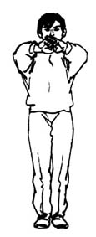 Fig 1 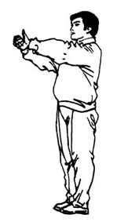 Fig 2
25.2 Mount the platform
Standing at the center of the platform, extend both arms sideways, palms up and pointing at the competitors (Fig 3). As a call on them to mount the platform, bend both arms at the elbow into a right angle, palms facing each other (Fig 4).
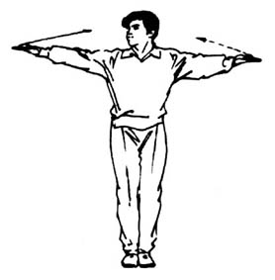Fig 3 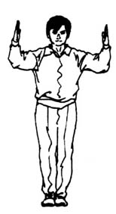 Fig 4

25.3 Competitors salute each other
Place the left hand on top of the right fist in front of the body as a signal to both competitors to salute each other (Fig 5).
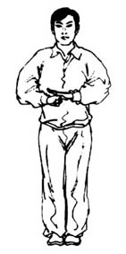Fig 5
25.4 First round
Facing the head judge, take a bow stance and, while calling “Diyiju（First round）!” extend one arm forward with the index finger pointing up and the other three fingers and the thumb clenched into a fist (Fig 6).
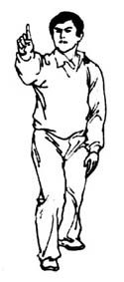Fig 6

25.5 Second round
Facing the head judge, take a bow stance and, while calling “Di’erju（Second round）!”, extend one arm forward with the index and middle fingers separated and pointing up, and the thumb and the other two fingers clenched (Fig 7).
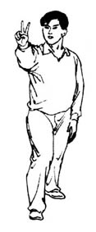
Fig 7
25.6 Third round
Facing the head judge, take a bow stance and, while calling “Disanju (Third round)!”, extend one arm forward with the thumb and the index and middle fingers separated and pointing up and the other two fingers clenched (Fig 8).
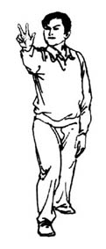Fig 8

25.7 “Yubei – Kaishi (Ready – Start)”
Take a bow stance between the two competitors and, while calling “Yubei (Ready)!" extend both arms sideways, palm facing up and pointing at the competitors (Fig 9). Then, while calling “Kaishi (Start)!” cross pronated palms in front of the abdomen (Fig 10).
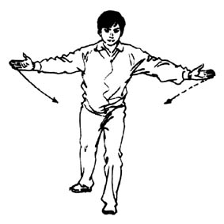Fig 9 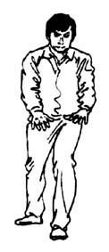Fig 10

25.8 "Ting (Stop)!”
While calling "Ting (Stop)!” take a bow stance and insert one extended arm between the two competitors, fingers pointing up (Figs 11-12).
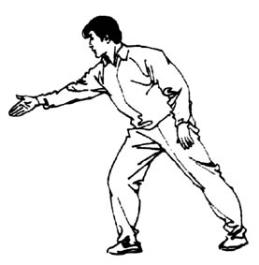Fig 11 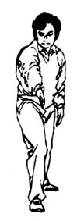Fig 12

25.9 5-second passivity
While calling "Hongfang (Red side)!” or “Heifang (Black side)!” raise both hands in front of the body, with the small and ring fingers of one hand bent and the thumbs and other fingers of both hands separated and stretched naturally (Fig 13).
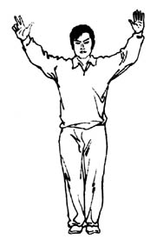 Fig 13
25.10 Forcible 10 Count
Facing the fallen competitor, with both arms bent at elbow and both hands clenched into fists in front of the body, palm side facing forward, unbend the fingers one by one from the thumb to the little finger, at an interval of one (1) second (Figs 14-15) to 10.
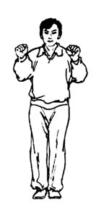 Fig 14 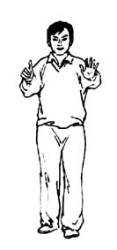 Fig 15

25.11 Passive hold
Fold the arms in front of the body (Fig 16).
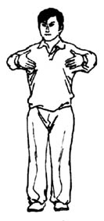 Fig 16
25.12 8-second forcible counting
Facing the head judge, extend one arm with the thumb pointing up and the other fingers clenched (Fig 17)
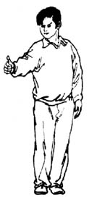 Fig 17

25.13 Three seconds
While calling "Hongfang (Red side)!” or “Heifang (Black side)!” extend one arm obliquely up with the palm supinated and pointing at the competitor. Meanwhile, move the other hand across the abdomen to the side of the body, with the thumb and the index and middle fingers separated naturally and the other two fingers clenched (Fig 18).
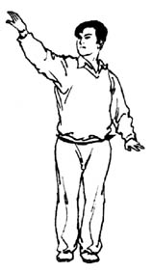 Fig 18
25.14 Appointed attack
Extend one arm between the two competitors, with the thumb extended and the fingers clenched, palm side down. While calling “Hongfang (Red side)!” or “Heifang (Black side)!” move the hand horizontally in the direction of the thumb as a signal for appointed attack (Fig 19).
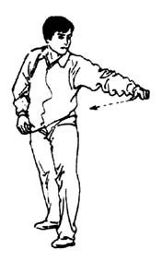 Fig 19

25.15 Down
While calling "Hongfang (Red side)!” or “Heifang (Black side)!” extend one arm with palm facing up and pointing at the fallen competitor, as the other arm moves to the side of the body, bent at elbow and with palm facing down (Fig 20).
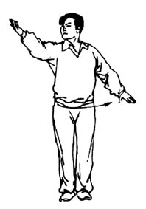 Fig 20
25.16 Down First
Extend one arm towards the competitor who is the first to fall down and, while calling "Hongfang (Red side)!” or “Heifang (Black side)!” cross the arms in front of the abdomen, palms facing down (Figs 21-22).
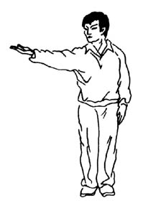 Fig 21 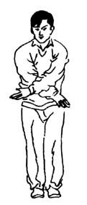 Fig 22

25.17 Simultaneous fall
Extend both arms horizontally forward and withdraw them to press both palms down (Fig 23).
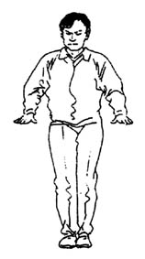 Fig 23
25.18 Kick the crotch
Extend one arm towards the offender and, while calling "Hongfang (Red side)!” or “Heifang (Black side)!” point the other hand at the crotch, palm facing inward (Fig 24).
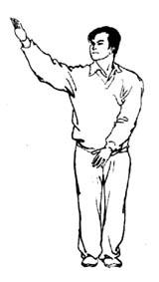 Fig 24

25.19 Hit the back of head
Extend one arm towards the offender and, while calling "Hongfang (Red side)!” or “Heifang (Black side)!” place the other hand on the back of the head (Fig 25) Attacks on the throat or the eyes should also be indicated by the platform referee.
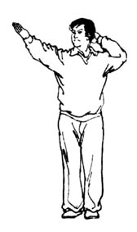 Fig 25
25.20 Serious Warning
Extend one arm towards the offender, palm up. While calling "Hongfang (Red side)!” or “Heifang (Black side)!” bend the other arm at elbow into a right angle, fingers clenched into a fist with the thumb side facing outward (Fig 26).
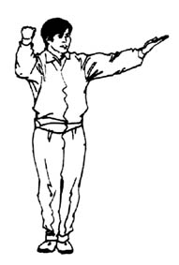 Fig 26

25.21 Technical Warning
Extend one arm towards the offender, palm up. While calling "Hongfang (Red side)!” or “Heifang (Black side)!” indicate the foul with the other hand and bend the arm at elbow into a right angle in front of the body, fingers pointing up and palm facing backward (Fig 27). (For a verbal warning, the referee only needs to point to the offender and indicate the non-Wing Chun movement used).
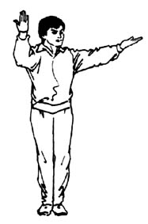 Fig 27
25.22 Disqualification
While calling "Hongfang (Red side)!” or “Heifang (Black side)!” clench both hands into fists and cross the forearms in front of the body (Fig 28).
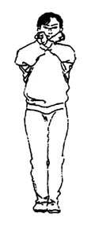 Fig 28

25.23 Not valid
Extend both arms and cross them in a swing in front of the abdomen (Figs 29.30.31).
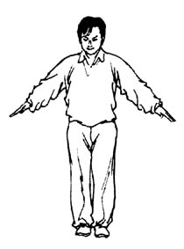Fig 29 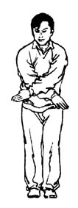Fig 30 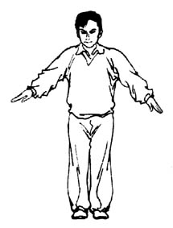Fig 31
25.24 Emergency treatment
Facing the medical supervision desk, cross forearms in front of the chest, fingers pointing up (Fig 32)
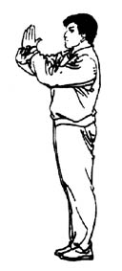 Fig 32
25.25 Rest
Extend both arms sideways, palms up, to point at the competitors’ rest places (Fig 33).
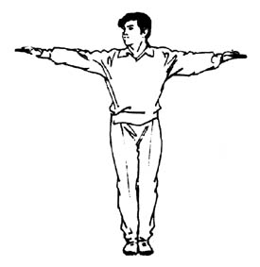 Fig 33
25.26 Exchange positions
Standing at the center of the platform, cross arms in front of the abdomen (Fig 34)
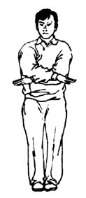 Fig 34
25.27 Draw
Standing between the competitors, hold their wrists and raise their hands. (Fig 35).
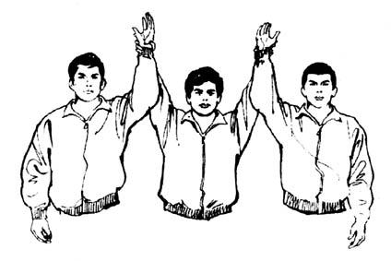 Fig 35
25.28 Winner
Standing between the competitors, hold the winner‘s wrist and raise his hand (Fig 36).
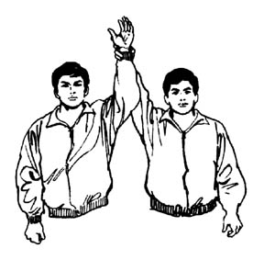 Fig 36

Article 26 Sideline Referee’ Gestures
26.1 Off or down
Point down with a forefinger, with the other four fingers clenched (Fig 37).
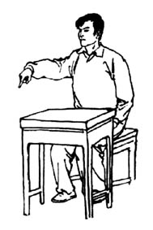 Fig 37
26.2 Not off or down
Move one hand from side to side once, fingers pointing up (Fig 38).
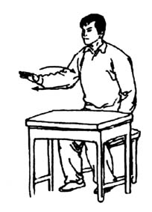 Fig 38
26.3 Not seen clearly
Bend both arms at elbow and spread forearms sideways in front of the body, palms up (Fig 39).
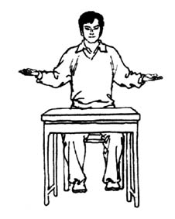 Fig 39

CHAPTER 7

COMPETITION AREA AND EQUIPMENT
Article 27 Competition Area
27.1 The competition area shall be a 1.6M x 1.6M platform, or surrounded by ropes.

Article 28 Equipments
28.1 Colored Plates
A total of eighteen (18) plates -- six (6) in black, six (6) in red, and six (6) half in red and half in black -- are used by the sideline judges to indicate the winner, the loser and a drawn bout respectively. The plate is a disc 20 cm in diameter, with a wooden handle 20 cm in length (Fig 1).
28.2 Technical warning cards
Twelve (12) 15cm X 5cm yellow cards are used for admonition, with the Chinese characters “技術警告” on them (Fig 2).
28.3 Serious warning cards
Six (six) 15cm X 5cm red cards are used for warning, with the Chinese characters “嚴重警告”on them (Fig 3).
28.4 Card Racks
Two (2) racks -- one in black and one in red -- are used for holding the cards. They are 60 cm long and 15 cm high (Fig 4).
28.5 Default plates
Two (2) yellow plates are used for default, with the Chinese characters “棄權” on them ― written in red color on one side and in black color on the other side. The plate is a disc 40 cm in diameter, with a wooden handle 40 cm in length (Fig 5).
28.6 Two (2) stop-watches (one as reserve)
28.7 Two (2) whistles (one with single pitch, the other with double pitches)
28.8 Three (3) megaphones
28.9 One (1) gong, with a rack and a hammer
28.10 Fifteen to twenty (15-20) tally counters
28.11 Two (2) video cameras
28.12 Two (2) metric scales
28.13 A wireless microphone (to be pinned on the platform judge’s chest)
28.14 One (1) set of electronic scoring system

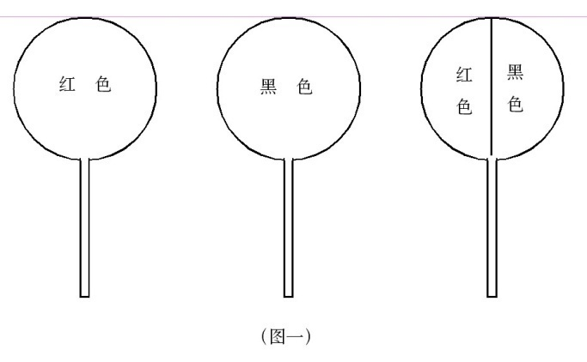
Fig 1
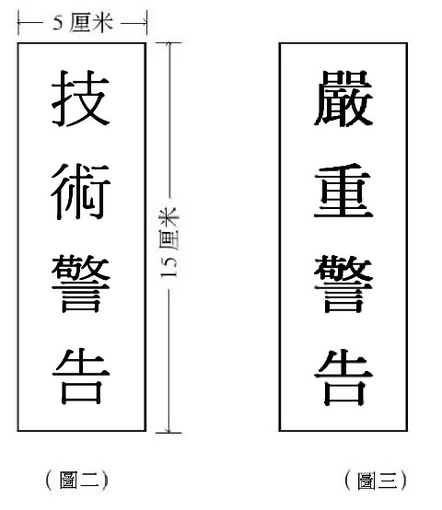
Fig 2 Fig 3

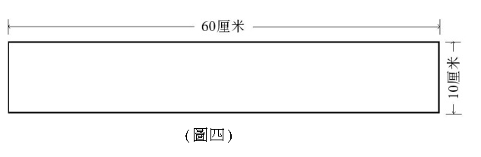
Fig 4
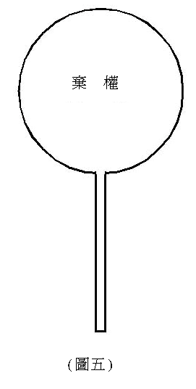
Fig 5

Wing Chun Sticking Hands Competition Entry Form (Table 1)
Country/Region： Team Leader： Coach： Doctor：
No. | Name | Sex | Birth y/m | Bodyweight | 48kg | 52kg | 56kg | 60kg | 65kg | 70kg | 75kg | 80kg | 85kg | 90kg | Over 90kg | Notes
Seal of Hospital : Date:____(year)/____(month)/____(day)
Seal of Association:

Wing Chun Sticking Hands Competition Schedule (Table 2)

Knockout competition (8 persons)
Number of bouts = n - 1 (n is number of persons)

1
8
5
4
3
6
7
2

Table 3 Assessment record of referee (Sticking Hands)
Item： Date:____(year)/____(month)/____(day)
Team: Name of contest:_______________________
competition  (no.) | aSSESment record |  | score | Final score
competition  (no.) | Marks | Marks deducted for error | score | Final score
1
2
3
4
5
6
7
8
9
10
11
12
Signature: ______________ Referee（no.）______
Wing Chun Sticking Arms Competition
Sideline Referee Scorecard (Table 4)

Category___________ Judge Number_______

Color | Name | Country/  Region | 1st Round | 2nd Round | 3rd Round
Red
Black
Remarks

Signature:_____________

Date of contest: ____(year) ____(month)____(day) Bout No.____

Wing Chun Sticking Arms Competition

Recorder’s Chart (Table 5)

Category: ____ Red: Weight: (kg) Black: Weight: (kg)
Penalty  Name  Round |  | Warning | Admonition | Forcible  counting | Off | Side-  line  Judge  (1) | Side-  line  Judge（2） | Side-  line  Judge（3） | Side-  line  Judge（4） | Side-  line  Judge（5） | Victory/Defeat | Note
First
Second
Third
Results

Head Judge: __ Recorder: ______ Date: ____(Year)/____(month)/____(day) Bout No. __

